There are 15 detectors in the selected freeway segment:

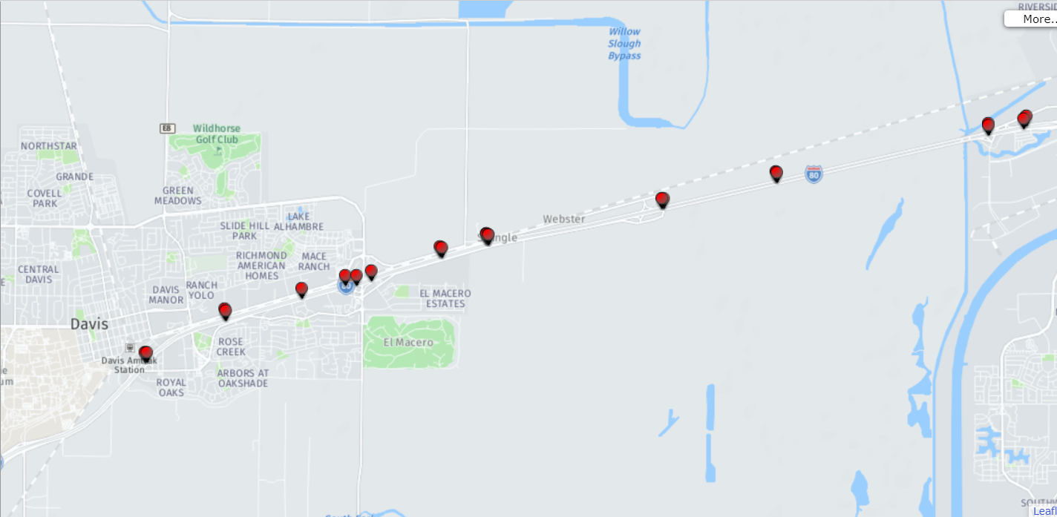

Actually, I have 4 data sets:

1. **The flow rate (vph) of 15 detectors** (resolution: 5 min)

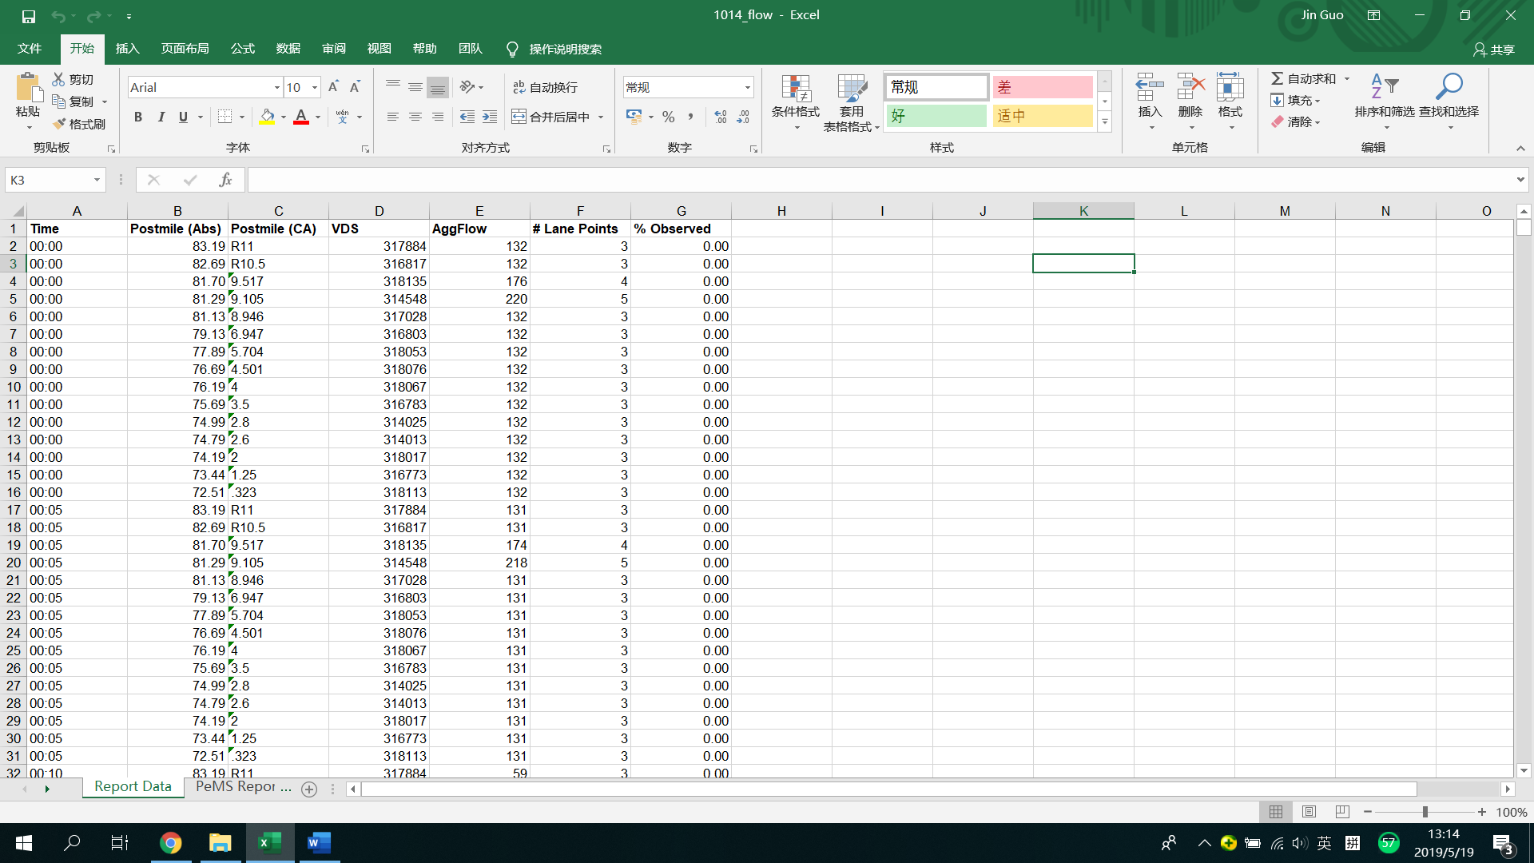

1. **The average vehicle speed (mph) of 15 detectors**(resolution: 5min)

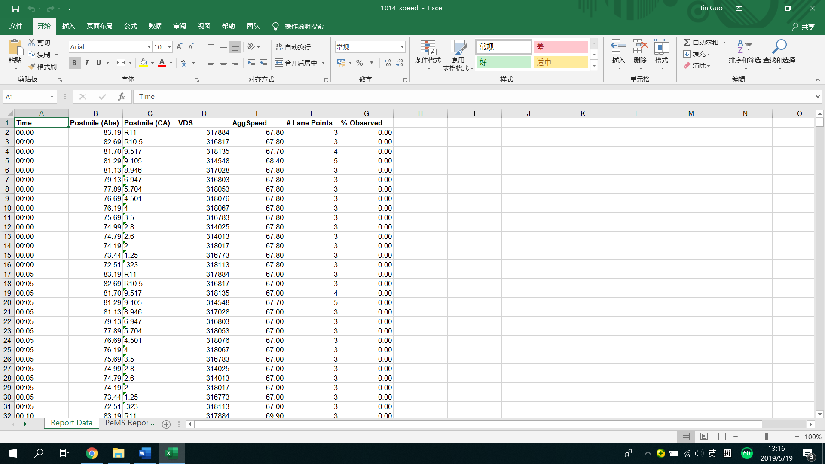

1. **The occupancy (%) of 15 detectors**(resolution: 5min)

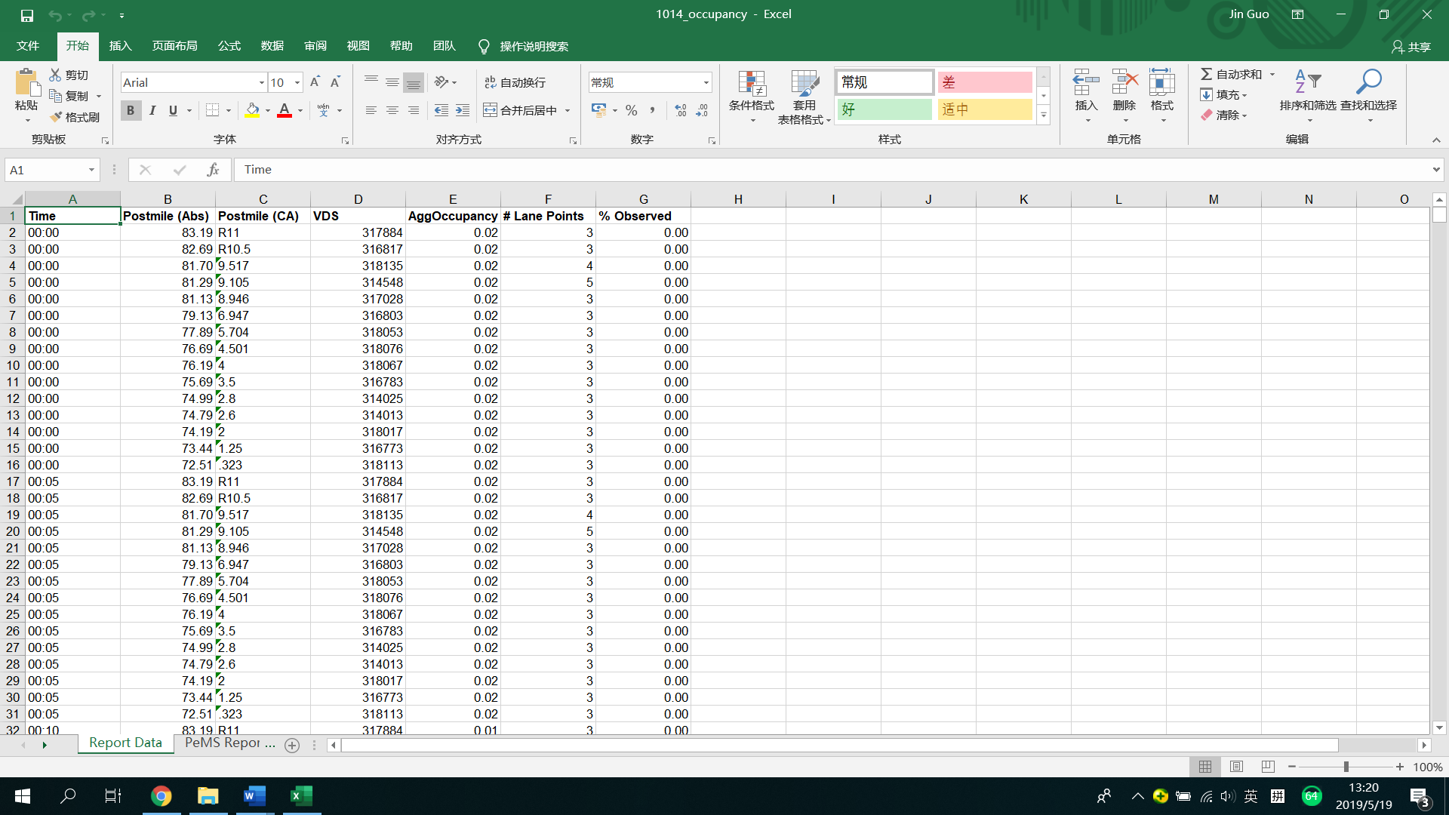

1. **Travel time (s) of selected freeway segment** (resolution: 5s, will be aggregated into 5 min).

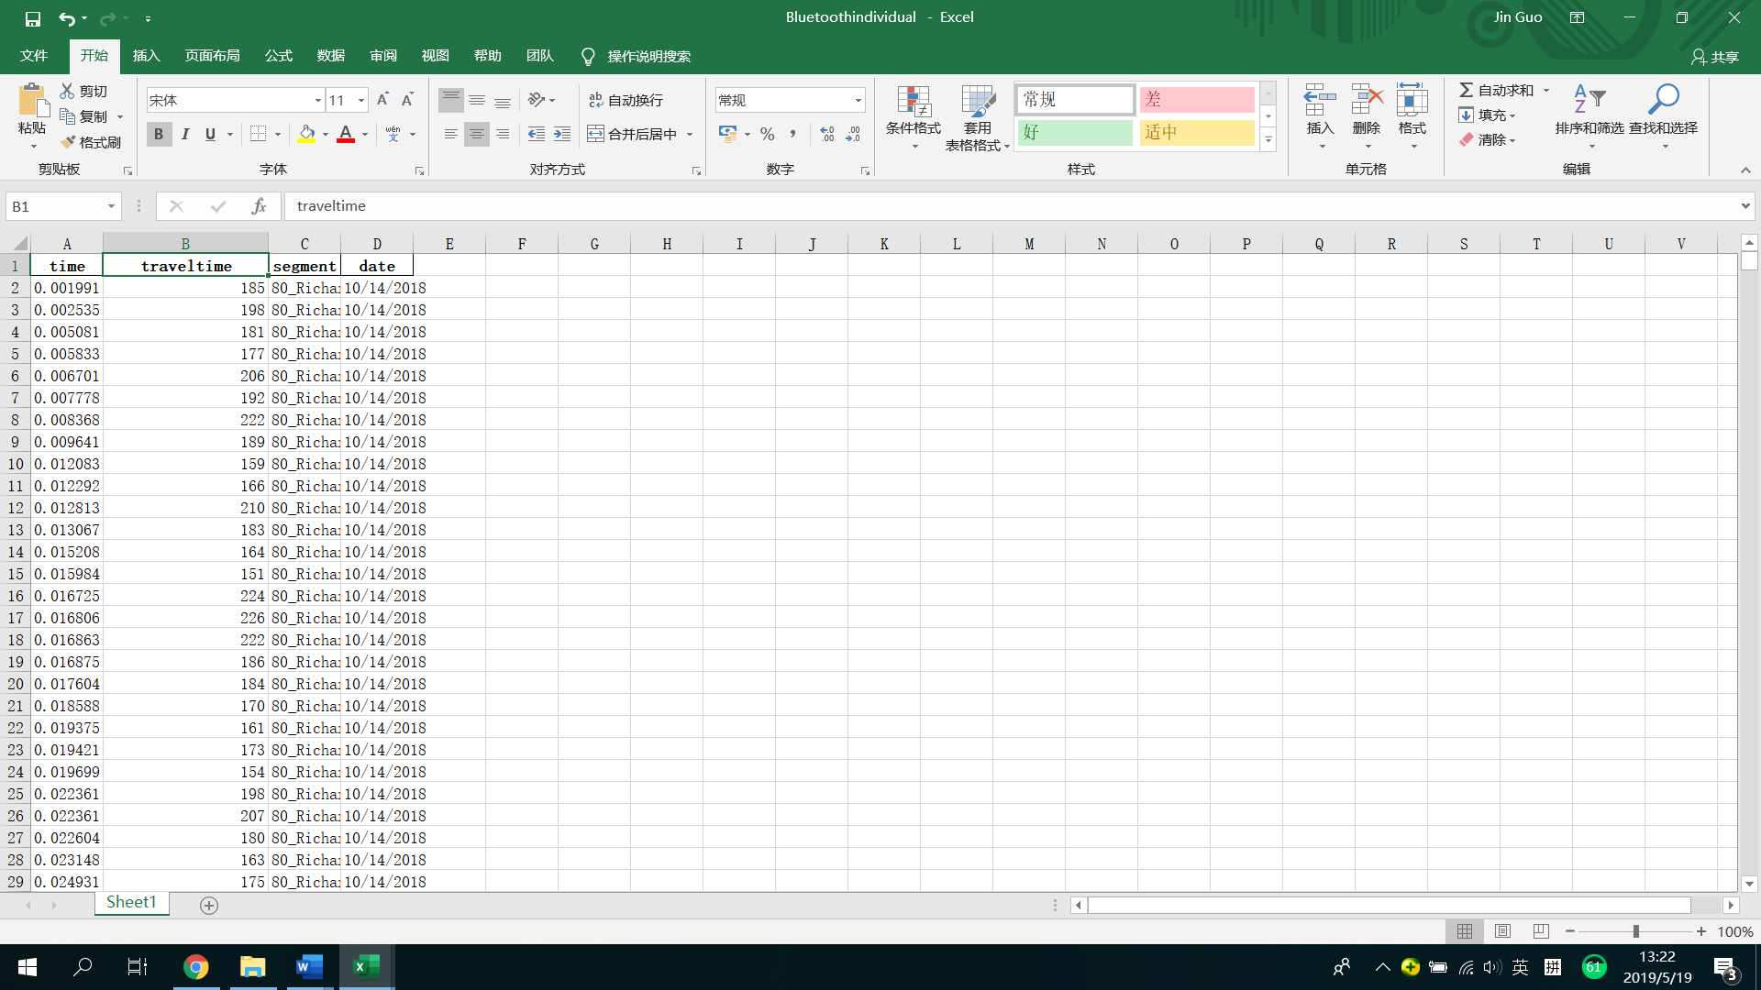

**Independent variables(Input of the** **convolutional neural network):**

Three channels of pictures generated by dataset 1-3, x-axis of the pictures is the sequence of 15 detectors, y-axis of the pictures is time series, pixel value is {flow rate, speed, occupancy}

I have not decided how long the time series of data to use(may be 30min or 1 hr)

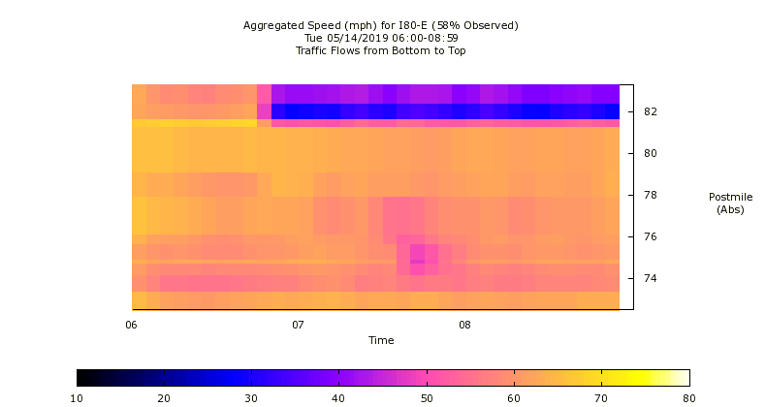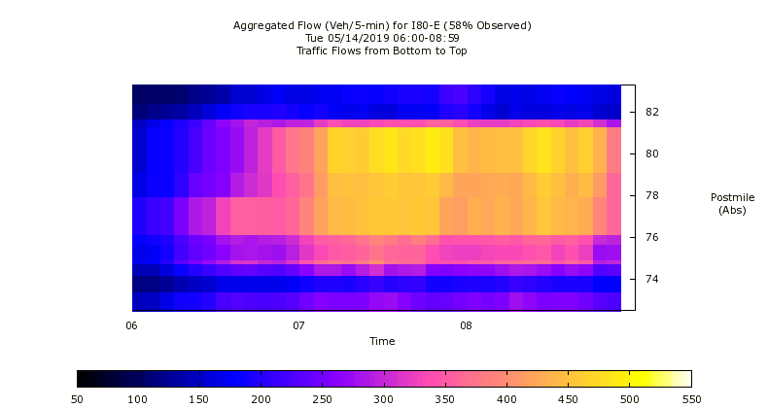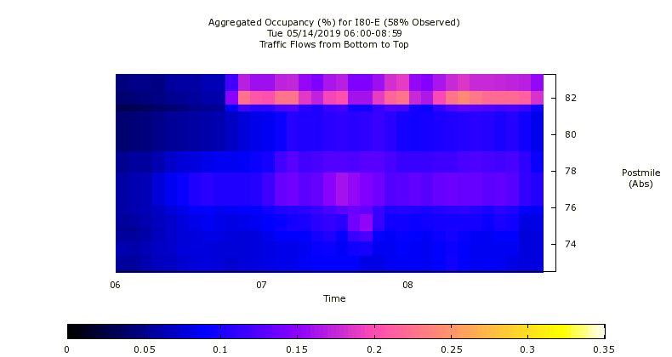

**Dependent variables (Output of the convolutional neural network):**

If the input images represent the spatio-temporal information of 6:00-7:00, the dependent variable (to be predicted) will be the travel of that freeway segemnt at 7:30.

**Architecture of CNN:**

